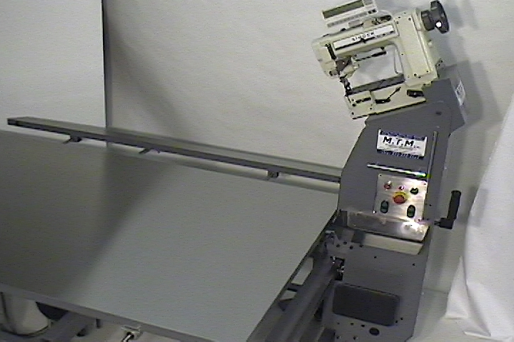

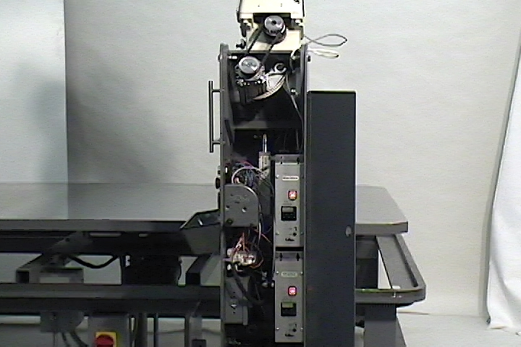
Dual Servo Drive Motors
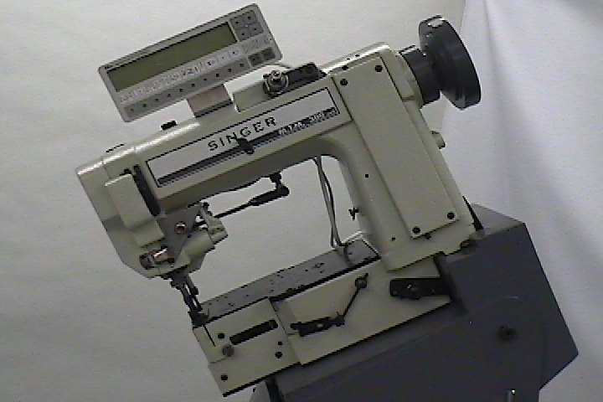
Micro speed adjustment for sewing head allows perfect synchronization with carriage
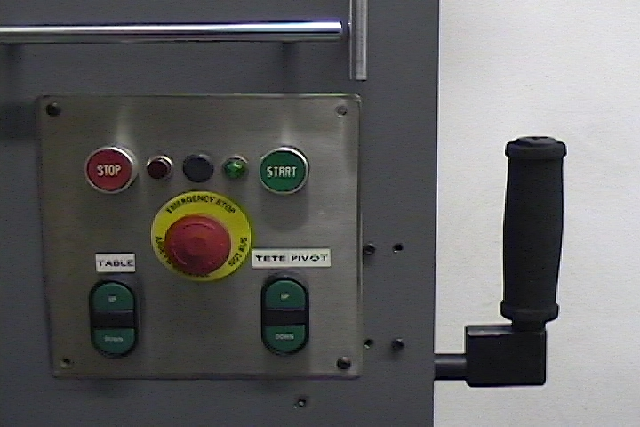
Convenient front mounted controls
Power table, Power tilt, Power head lift
Micro speed adjustment for sewing head
allows perfect synchronization
with carriage

Power glide, Carriage is powered forward & reverse electronically at the touch of the control handle

NEW MTM Singer sewing head designed for tape edge, not a used modified head.
- Dual electronic servo motors independently control sewing head speed & carriage movement. This eliminates the clutch and its maintenance
- Power table lift & sewing head tilt
- Micro speed adjustment for sewing head allows perfect synchronization with carriage
- Feather touch solid-state knee control
- Electronic braking, no maintenance
- Auto slow-down at corners, tamper proof
- Shock absorber for smooth corner transition
- Electronic needle positioning (no synchronizer)
- Table travel 25” to 38”, gives operator comfortable table height
- Stainless steel queen size top
- Stainless steel end cover on sewing head base
- Under table wiring meets UL standards
- Rugged steel frame & heavy-duty center column
- Standard block binders for woven tape in stock
- High lift (7/16”) walking presser foot
- Power glide, Carriage is powered forward & reverse electronically at the touch of the control handle
- MTM Singer 300VX5 sewing head, standard replacement parts in stock

