Panel Binder Singer 300W Walking Foot

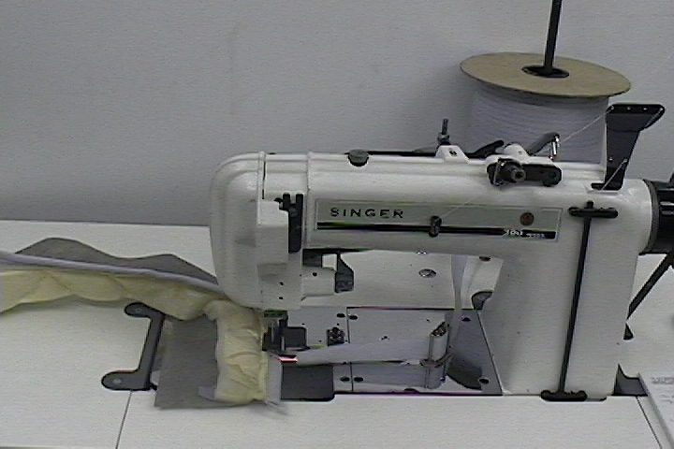

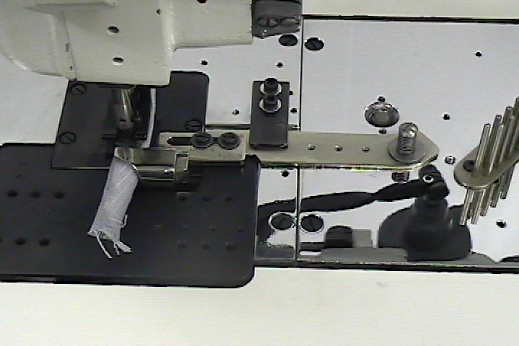
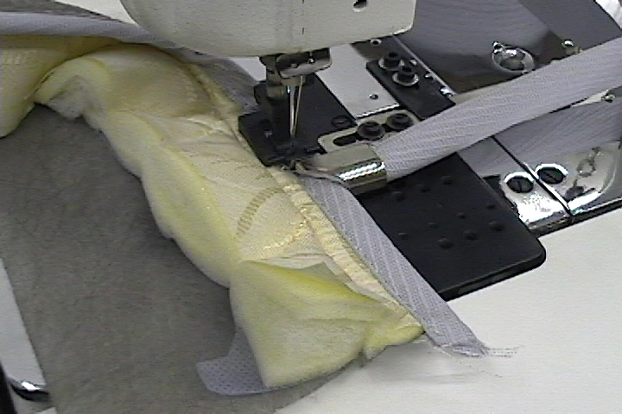

Heavy duty sewing head
Electronic motor with needle positioner & foot lift
Swing Bracket Folder

