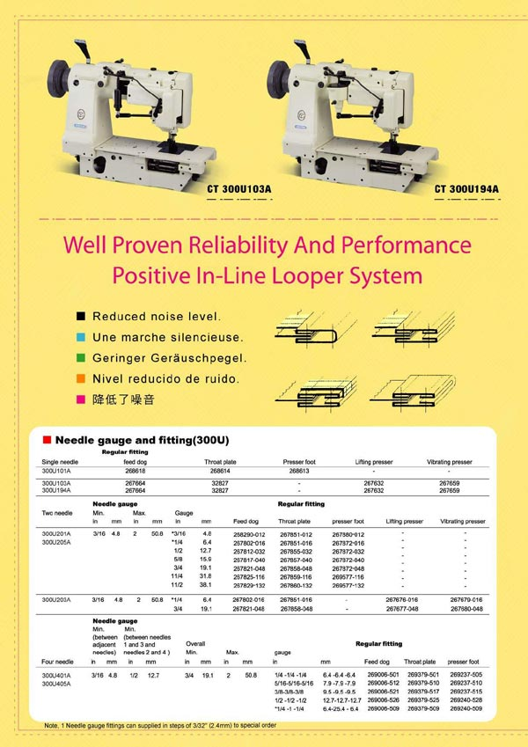
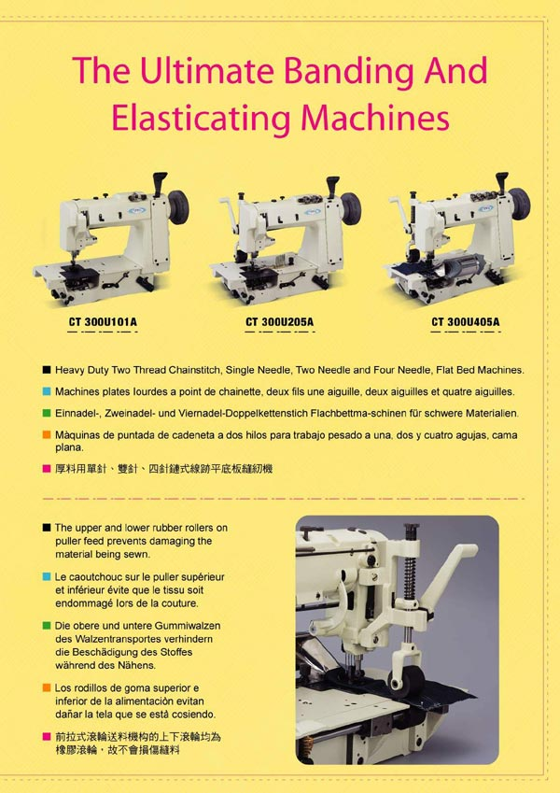
Heavy Duty Chainstitch Sewing Machines
- 101A - Single Needle, Needle Feed Sewing Machine.
- 103A - Single Needle, Walking Foot Sewing Machine, with regular cylinder.
- 194A - Single Needle, Walking Foot Sewing Machine, with stronger cylinder.
- 201A & 205A - Twin Needles, Needle Feed Sewing Machine.
(Gauge size is inter-changeable, please e-mail us for details.)
- 203A - Two Needles, Walking Foot Sewing Machine.
(Gauge size is inter-changeable, please e-mail us for details.)
- 401A & 405A - Four Needles, Needle Feed Sewing Machine.
(Gauge size is inter-changeable, please e-mail us for details.)

