Source http://www.intlsew.com/industrial_4-1.htm

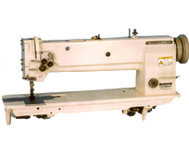

LONG-ARM, COMPOUND FEED MEDIUM
& HEAVY DUTY LOCKSTITCH SEWING MACHINE

